INTERNATIONAL UNIVERSITY – VNU HCM
Net-Centric Programming
LAB 06
Ta Thanh Vu - ITITIU21352

Task 3: Book Catalog Service with Database
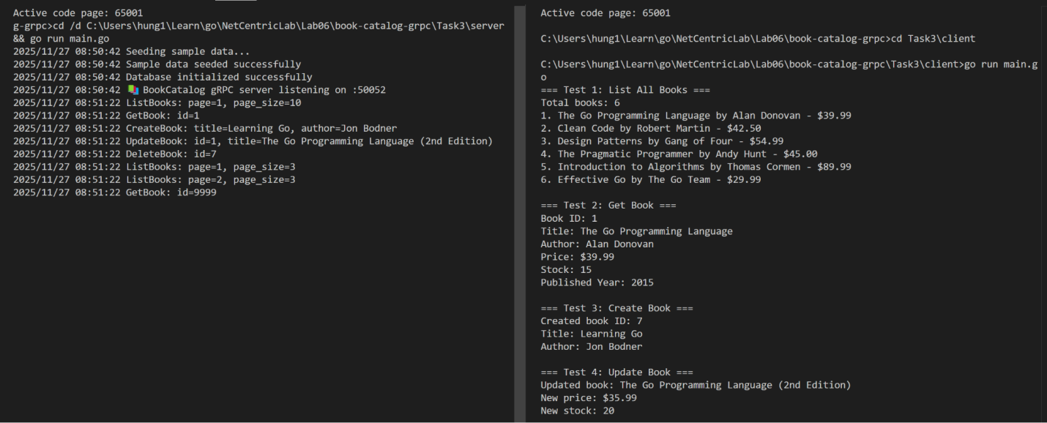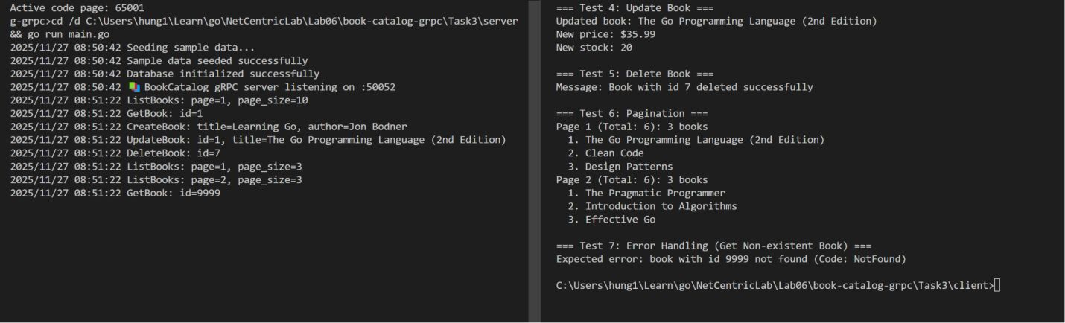

Task 4: Advanced Search and Error Handling
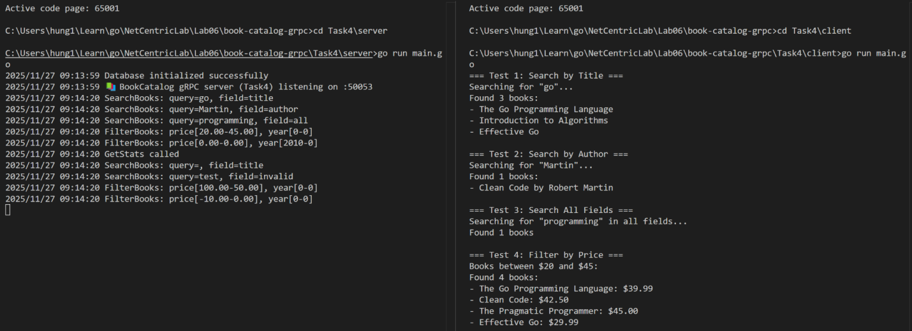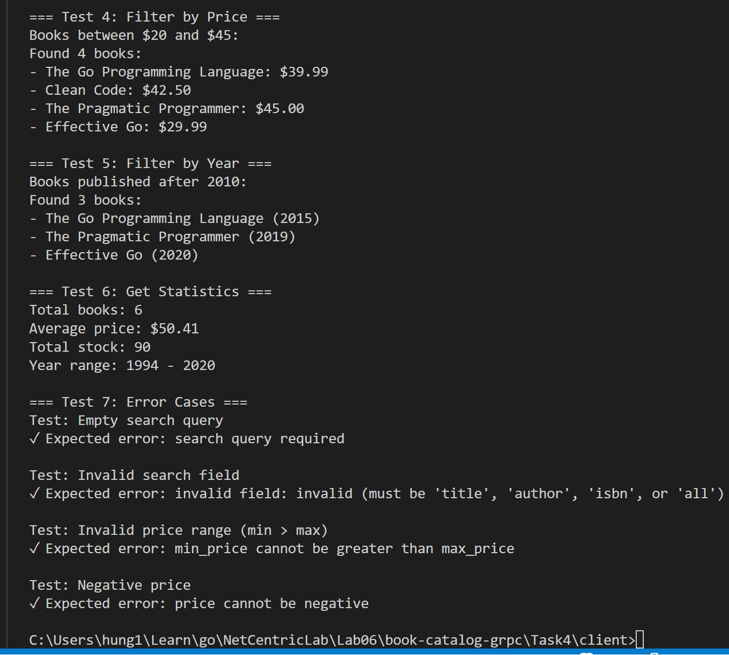

Task 5: Complete Microservice with Multiple Services
